[TC-MR12-37] Official Quote Automation – Finalize/Update Official Quote

Result 1: BUG

Testing sequence 1
1. New range defined for EEAS 2016.
2. Select "New Official Quote" from the form "Select Official Quote Mode"
3. Click "OK" to display "Request Official Quote". The form displays with EEAS 00001 value (default)
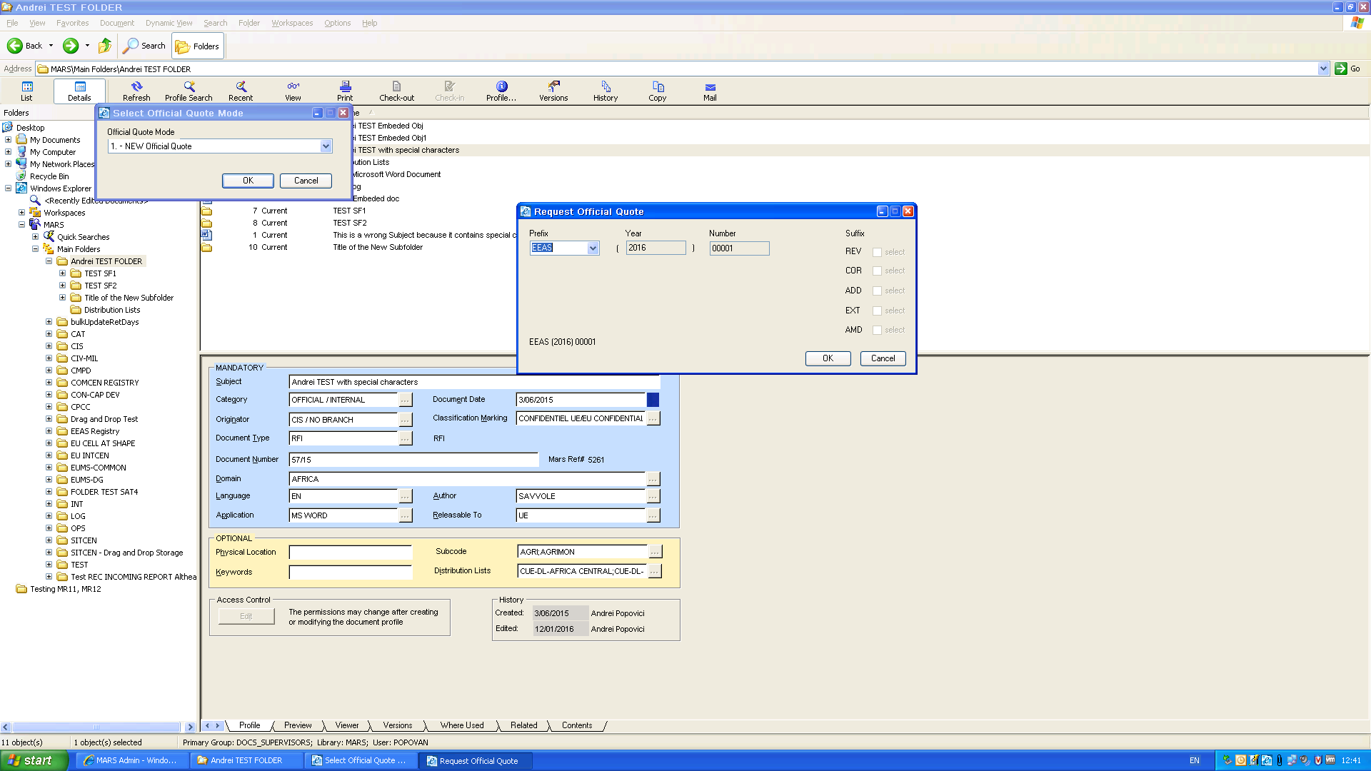
4. Click "Cancel";
5. Click "Cancel " in "Select Official Quote Mode". The EEAS index remain 00001.
6. Repeat from step 2-3. The form displays with EEAS 00002 value.
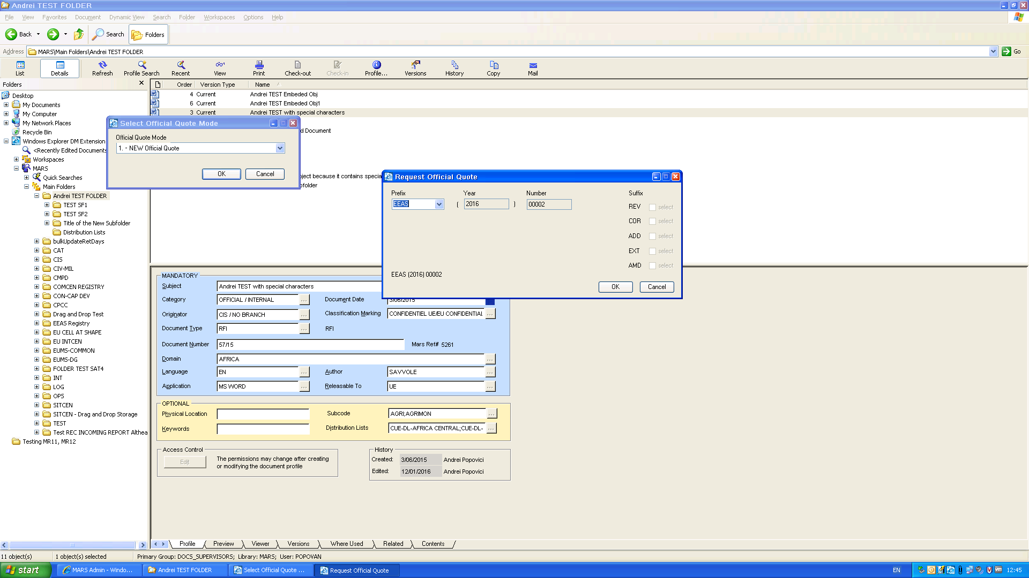
The accidental reset to EEAS 00001 described above and the rest of the steps are not recorded in the log :
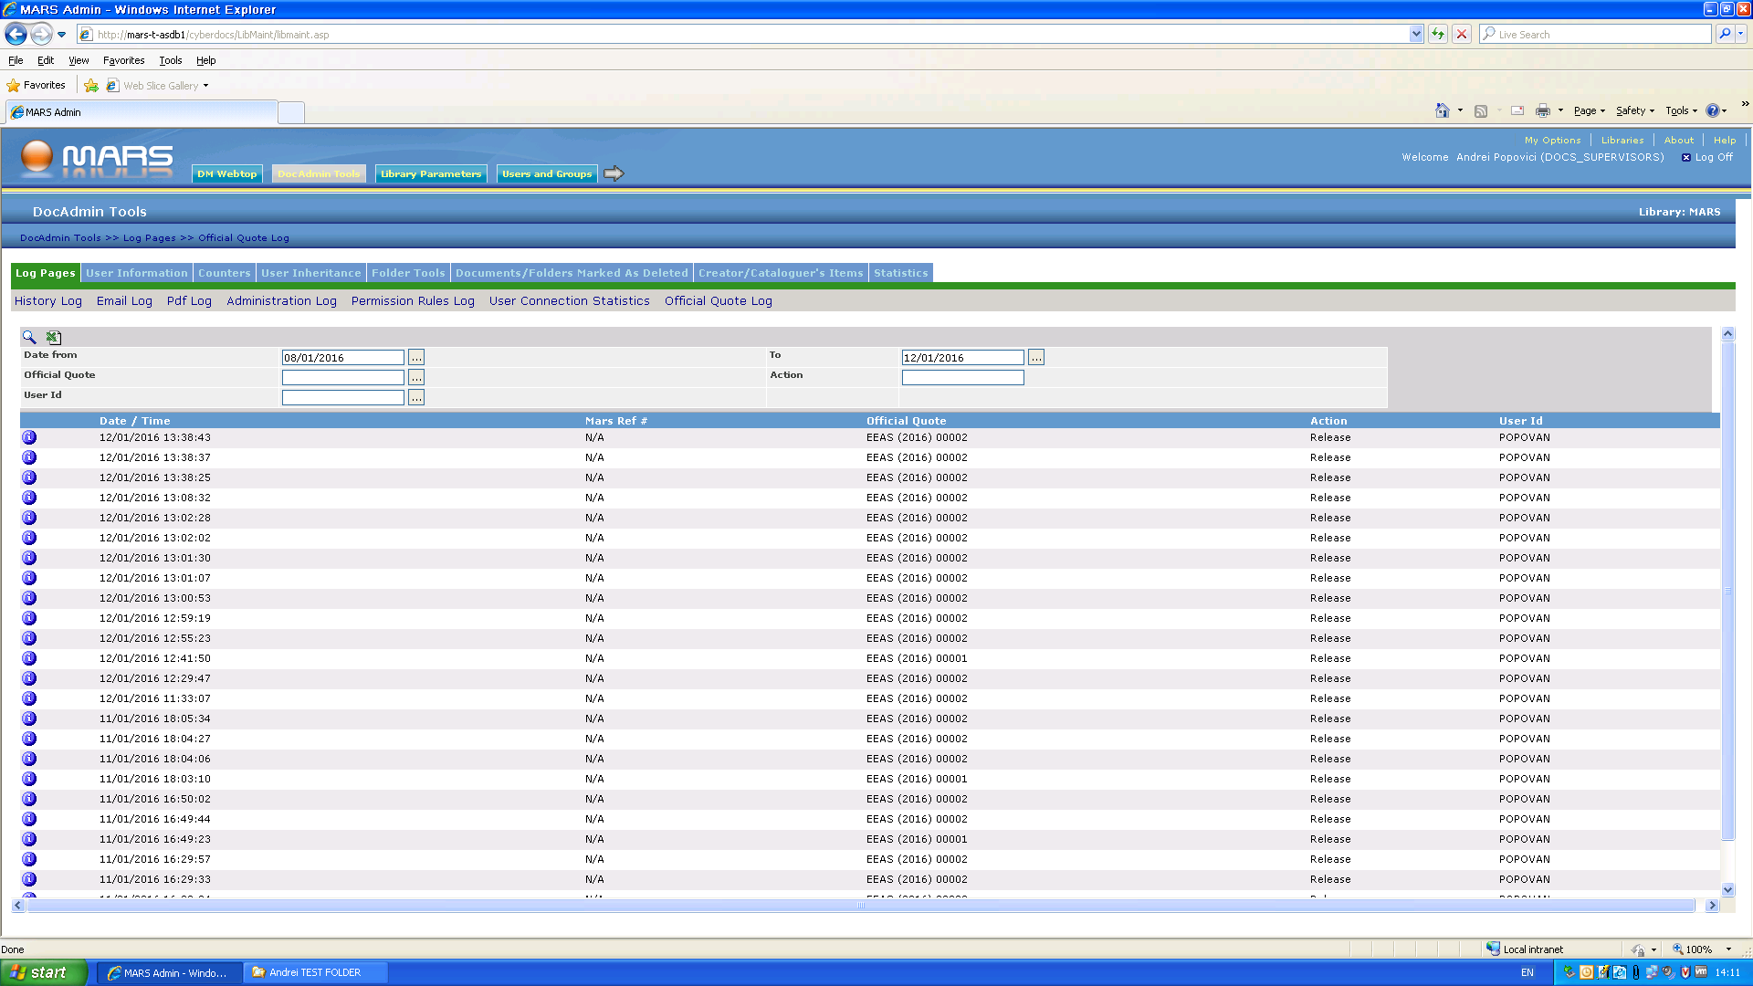

1.2Testing sequence 2
1. Repeat Steps 1, 2 from "Testing sequence 1" to see the first value of EEAS official quote available.
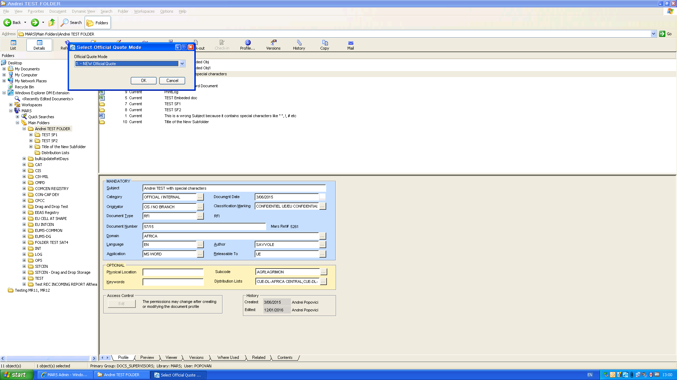
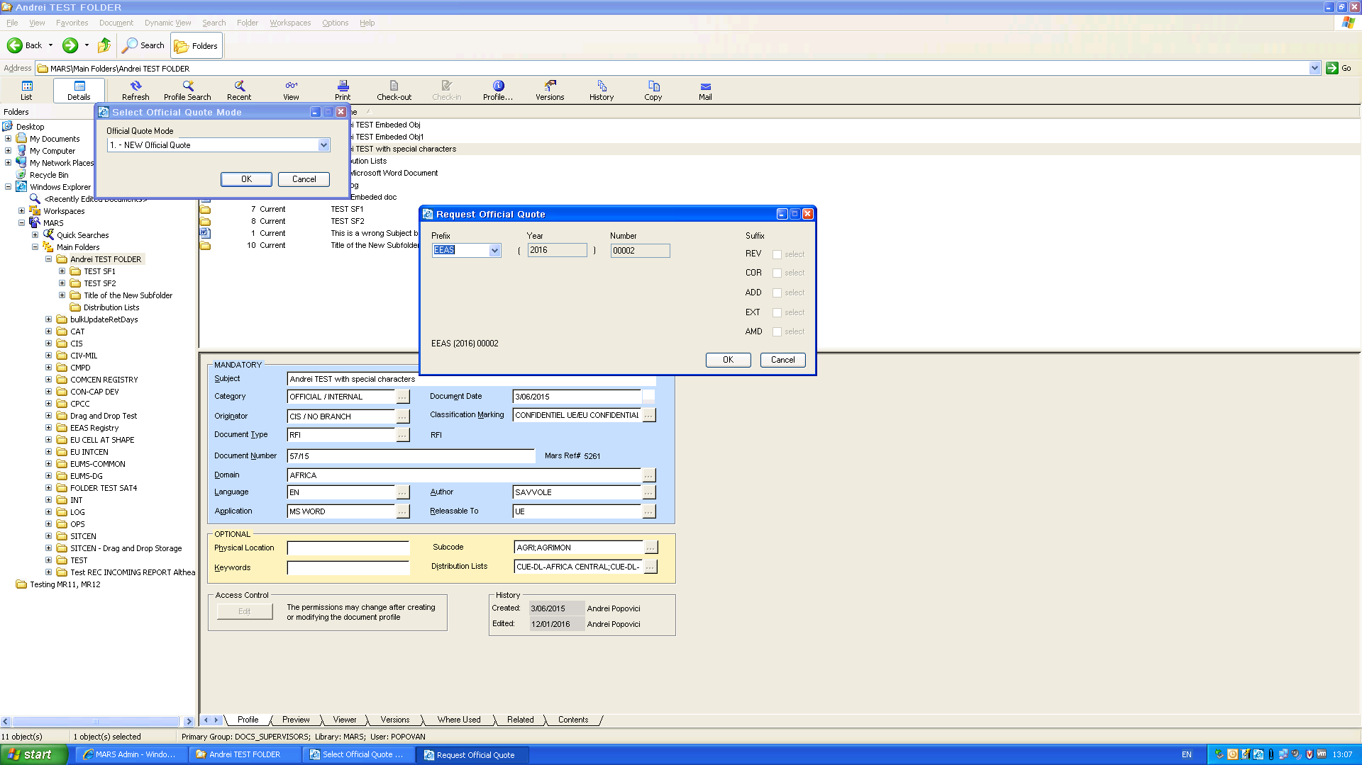
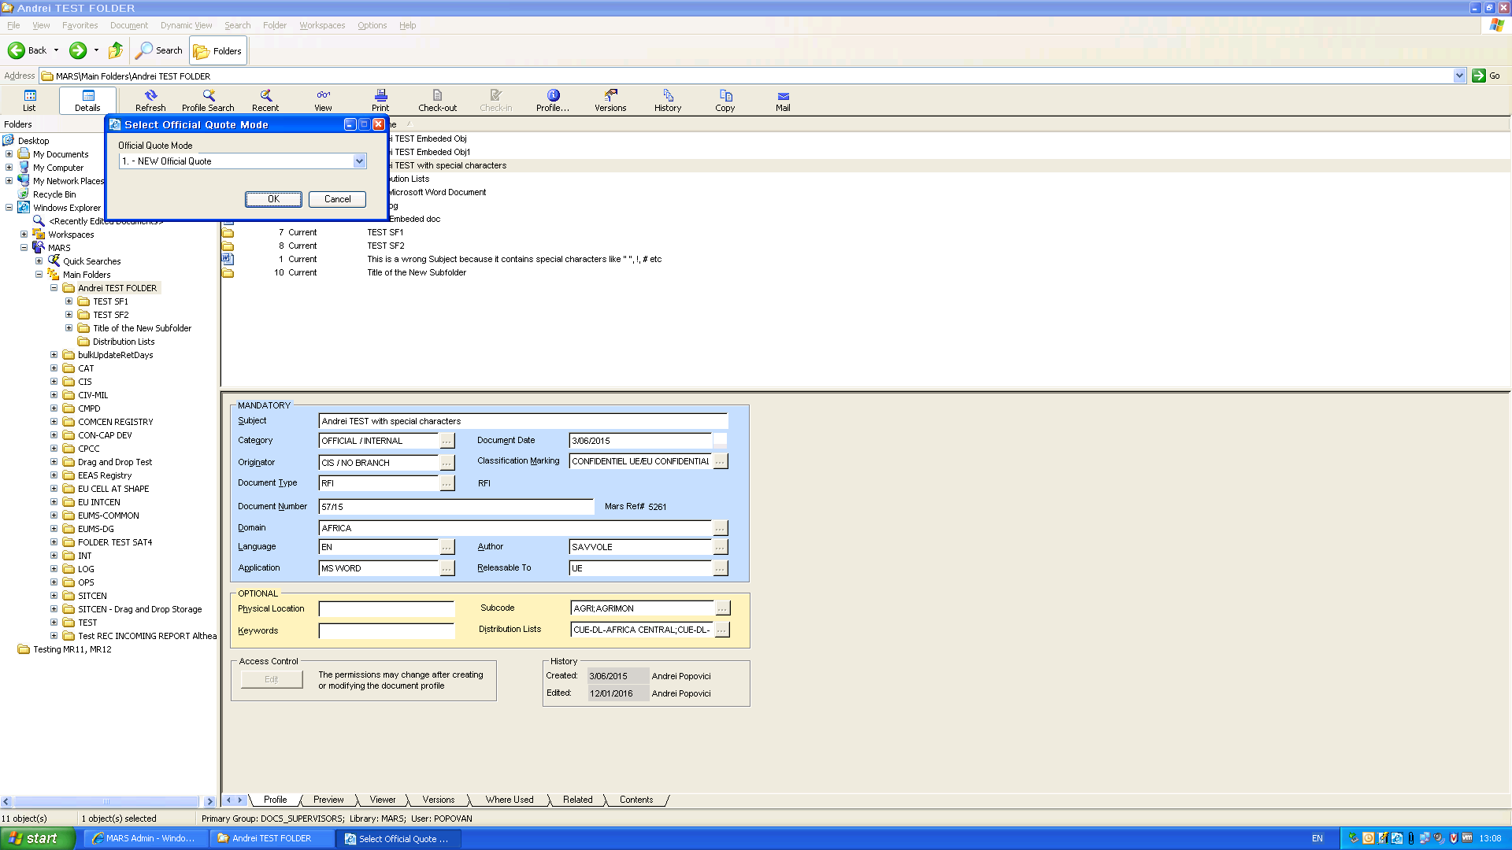
2. Click "Cancel" in "Select Official Quote Mode".
3. Select "Finalize" from the right click menu for one document.
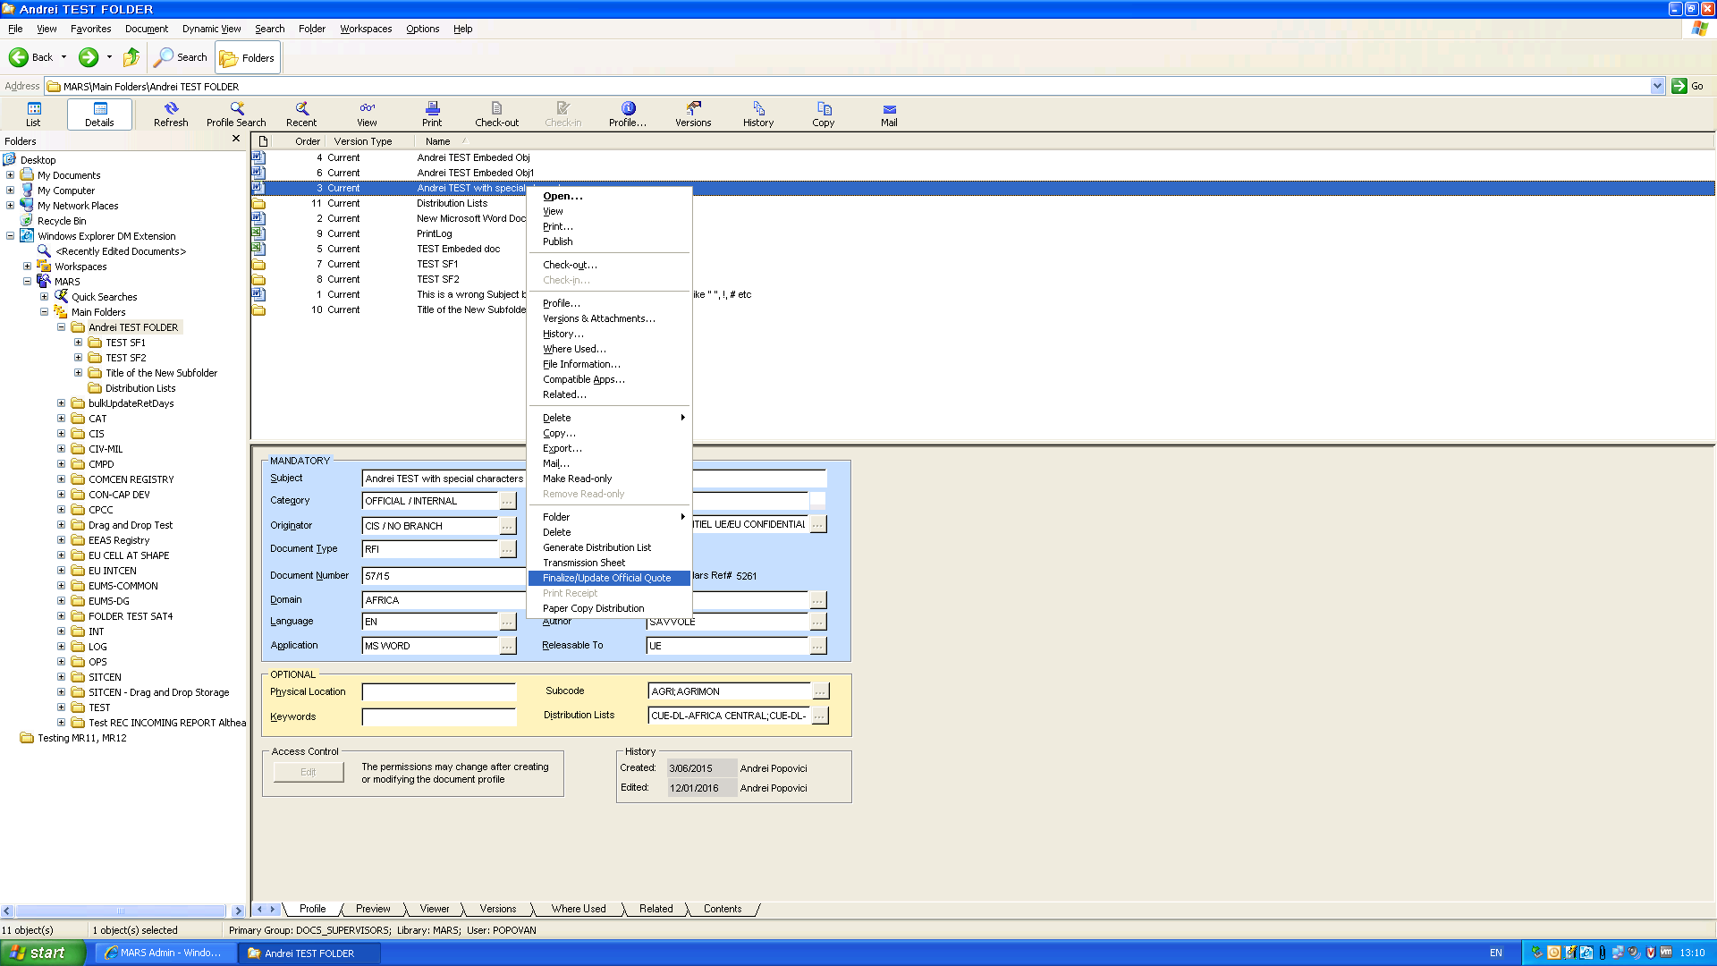
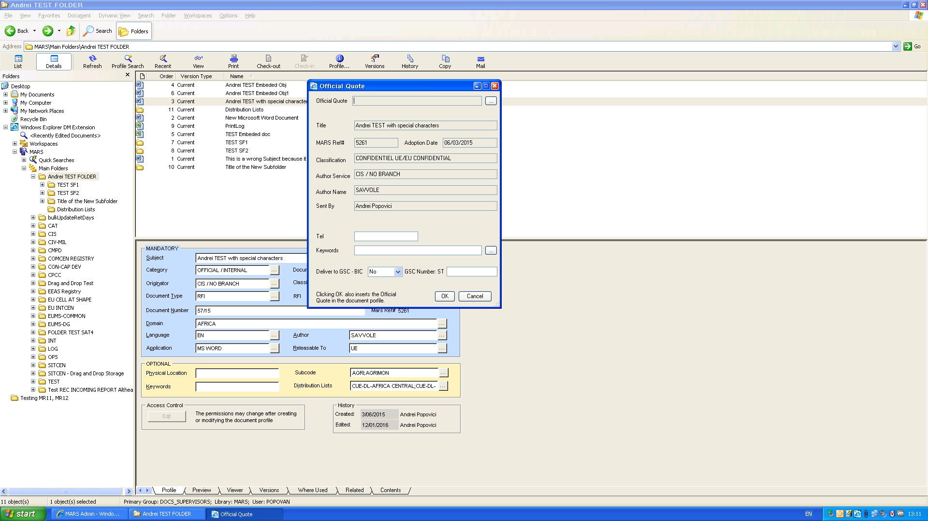
4. Click on the button for closed list of booked Official Quotes:
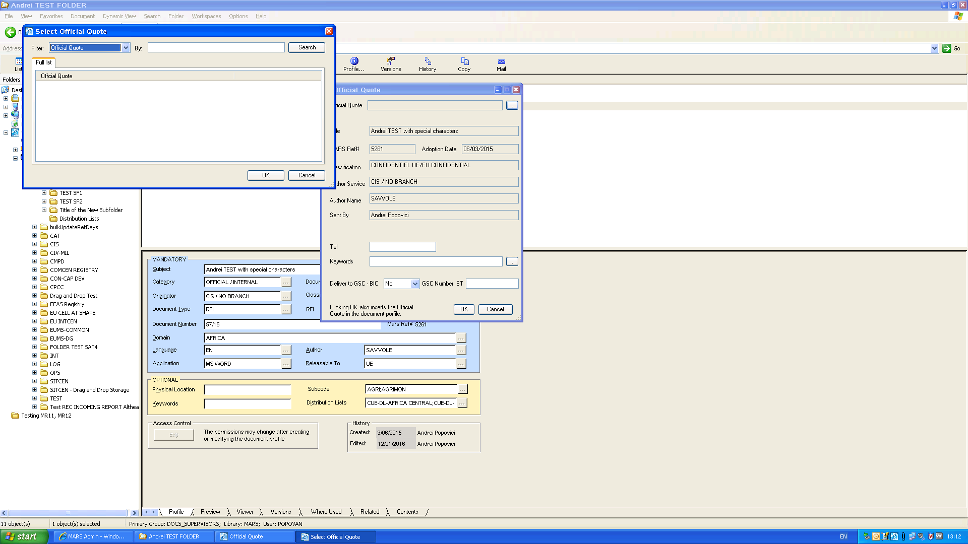
The list is empty. EEAS 00001 is not available, even though the application showed as available EEAS 00002 which means EEAS 00001 has been booked already. Which actually is not true, could be a fake saving…
As a consequence, I cannot select the (supposed) available EEAS 00001 value from the list –it is empty - and cannot finalize the official quote.
REM: If we choose "New Suffix" option in "Select Official Quote Mode" form, then we get a list populated with EEAS 00001 value. We click "Cancel" (see also BUG 1 for [TC-MR12-38] Official Quote Automation – Request Official Quote – Suffix).
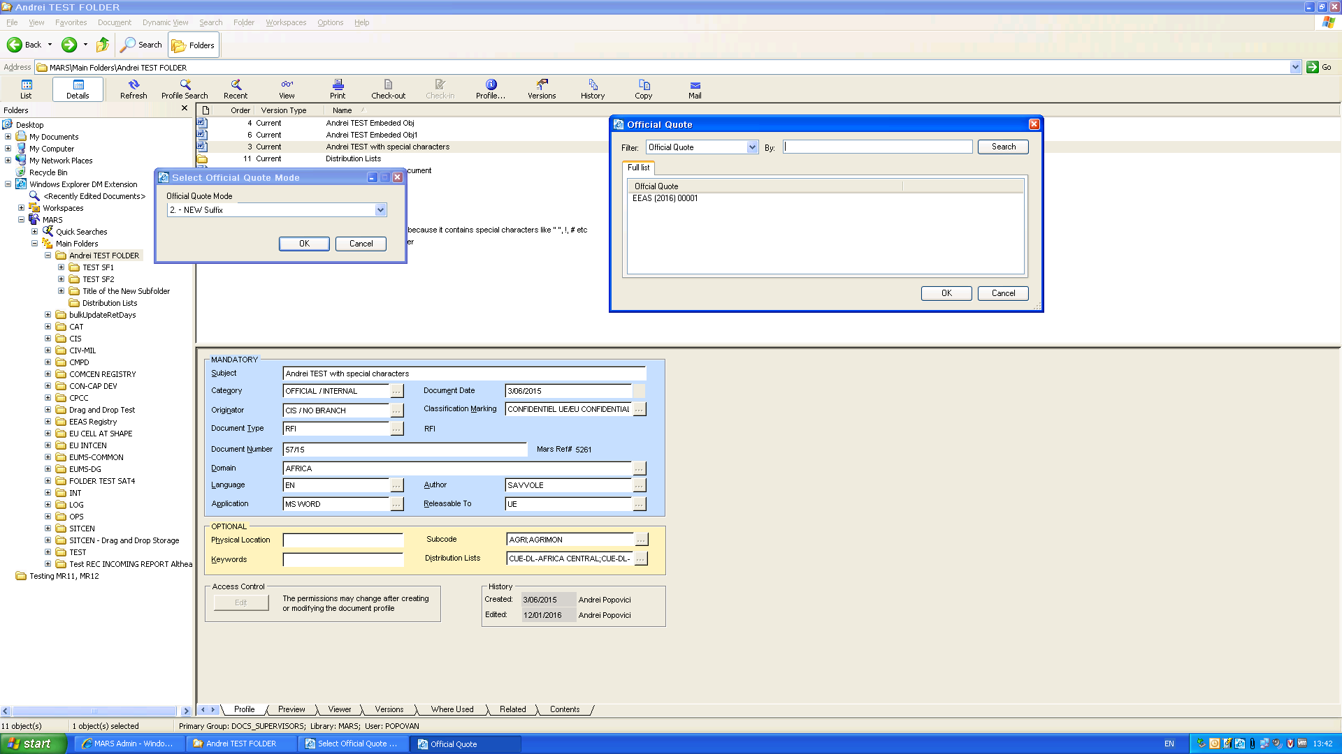

Result 2: BUG

Testing sequences regarding ADMIN 00001 prefix to show that ADMIN 00001 is stable, in comparisson with EEAS 00001.
1. New range defined for ADMIN 2016 (1-99)
2. Select "New Official Quote" from the form "Select Official Quote Mode"
3. Click "OK" to display "Request Official Quote". The form displays ADMIN 00001 value (default)
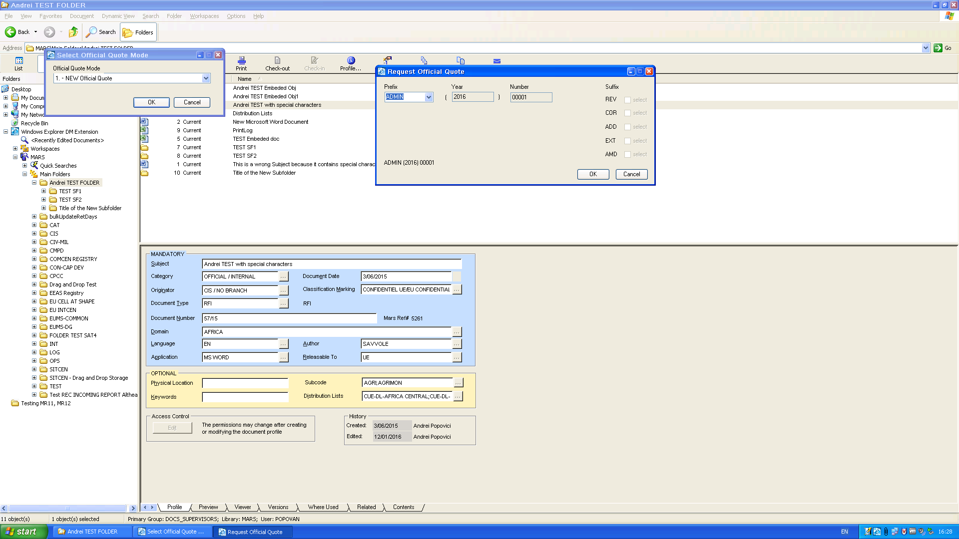

4. Click "Cancel";
5. Click "Cancel "in "Select Official Quote Mode". The ADMIN index remains 00001.
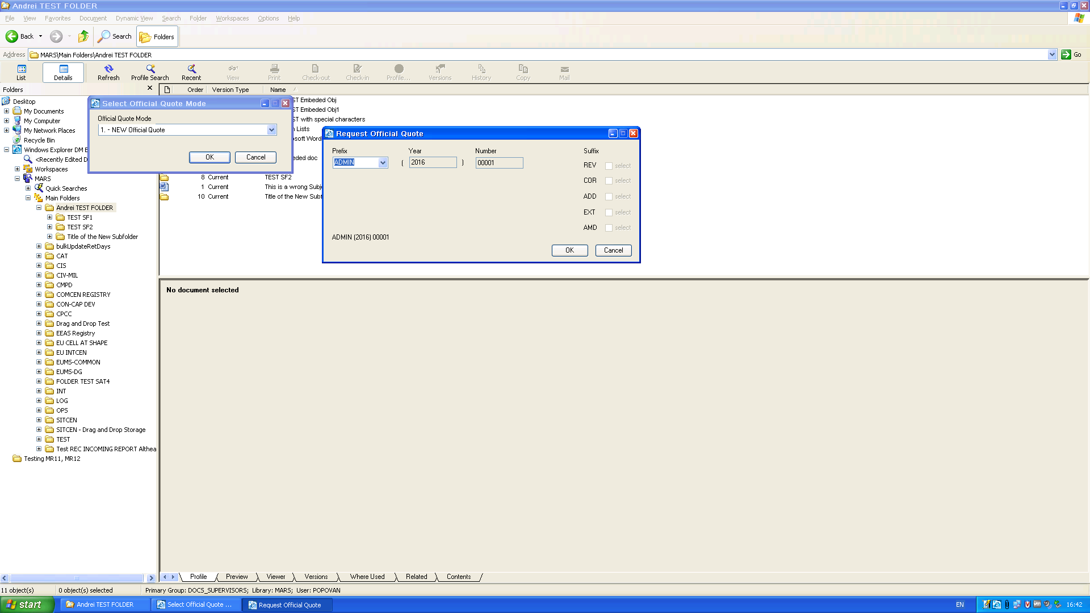

2.2 Testing sequences regarding booking of 3 Official Quotes for HR-COM prefix:
1. New range defined for HR-COM 2016 (1-99)
2. Select "New Official Quote" from the form "Select Official Quote Mode"
3. Click "OK" to display "Request Official Quote". The form displays HR-COM 00001 value (default)
4. Click "Cancel";
5. Click "Cancel "in "Select Official Quote Mode". The HR-COM index remains 00001.
6. Select "OK" to book HR-COM 00001 | 2 | 3. It books OK the 3 values. Next value available:
HR-COM 00004.
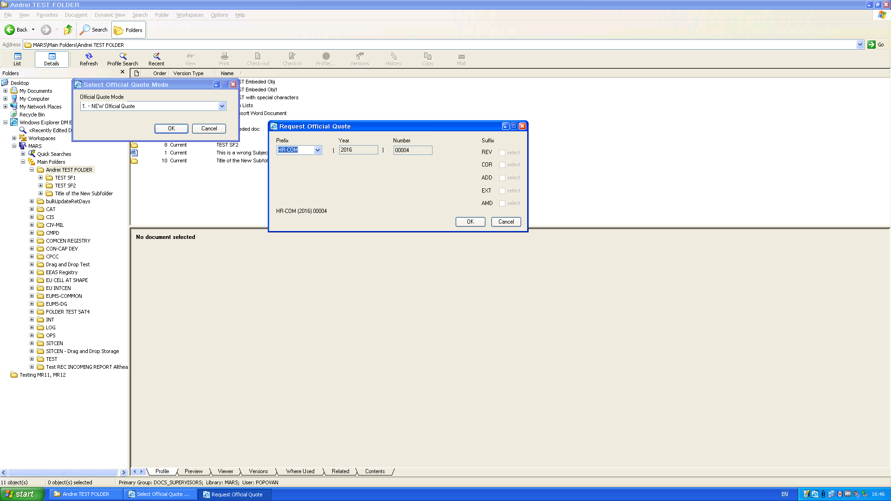
7. Click "Cancel". The last booked Official Quote is HR-COM 00003. We should see them available in the closed list when we select "Finalize…"
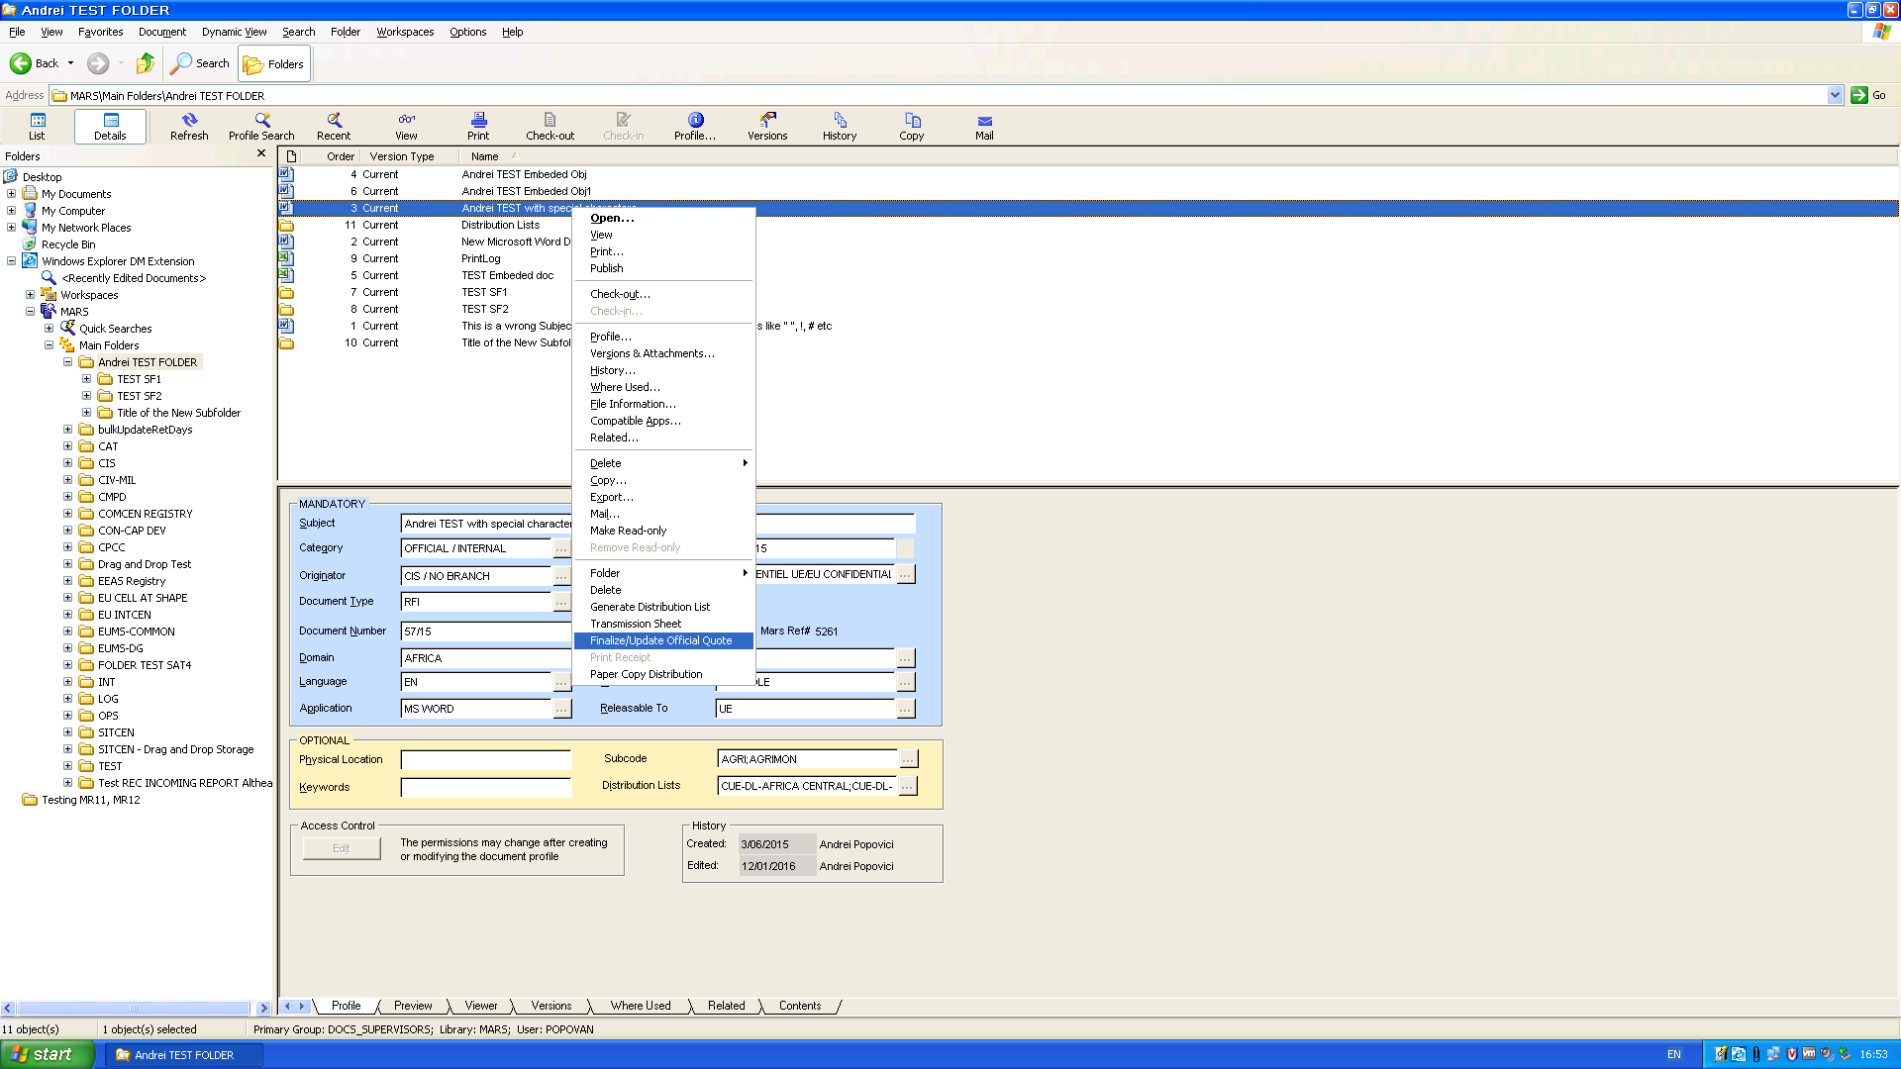
The 3 indexes from HR-COM are available in the list:
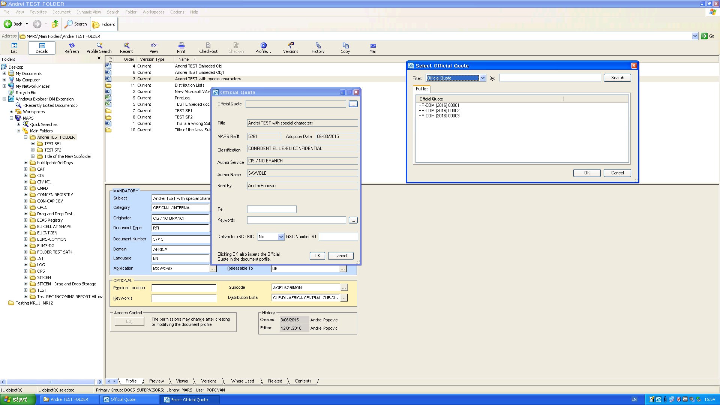
Click "Cancel" here.

2.3 Testing sequences regarding booking EEAS 00002, EEAS 00003 and ADMIN 00001, ADMIN 00002 and ADMIN 00003.
We also book EEAS 00002, EEAS 00003 and the same for ADMIN prefix, and expect to see them all in the list:
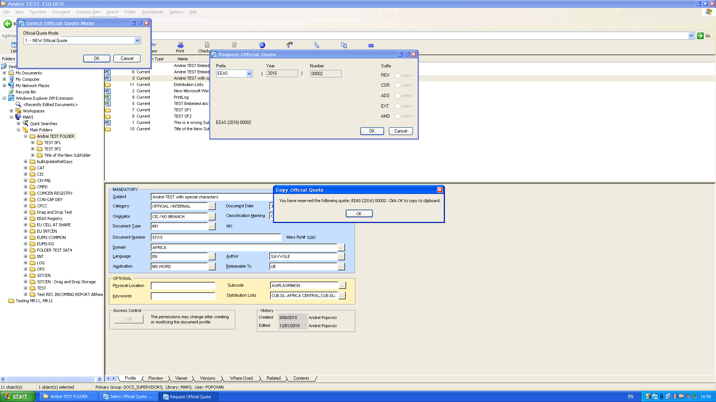
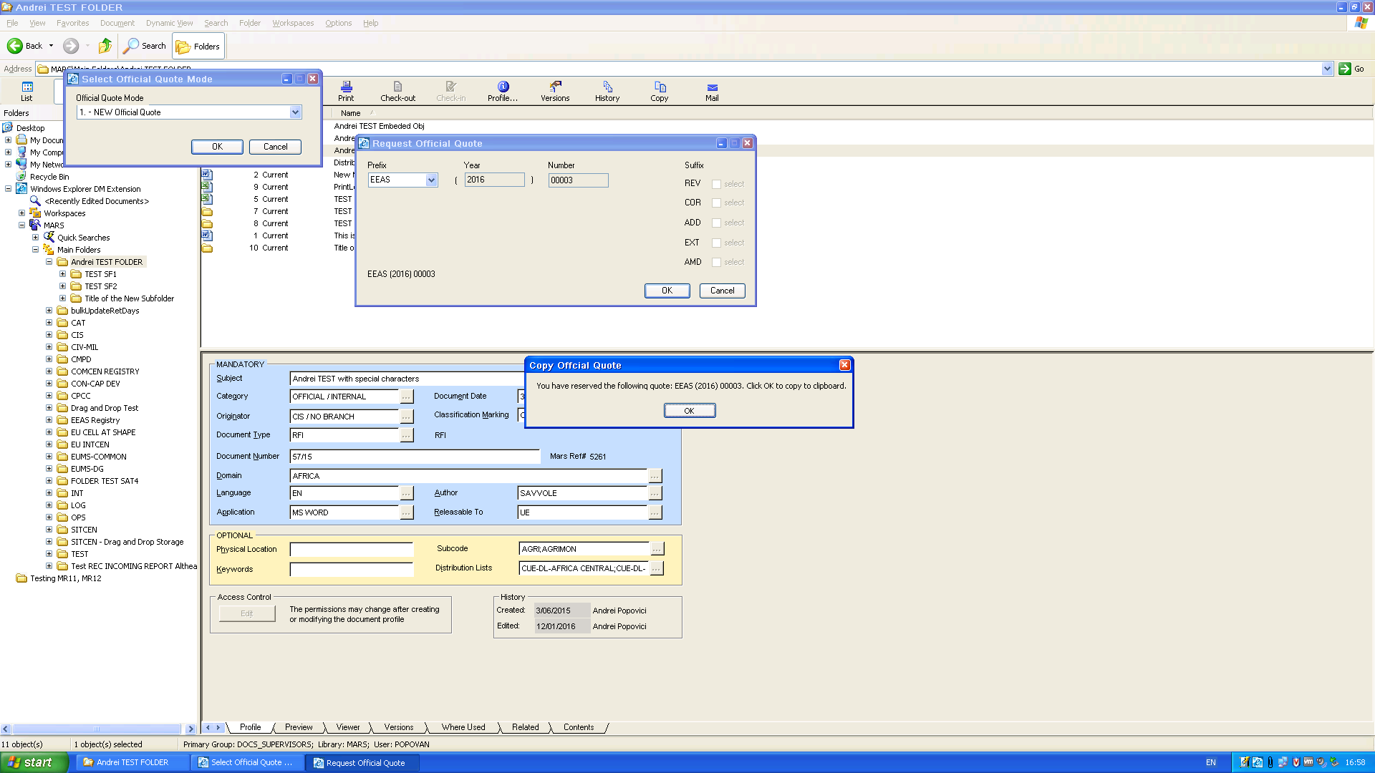
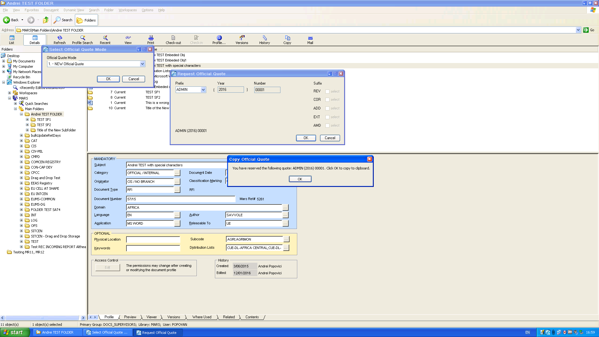
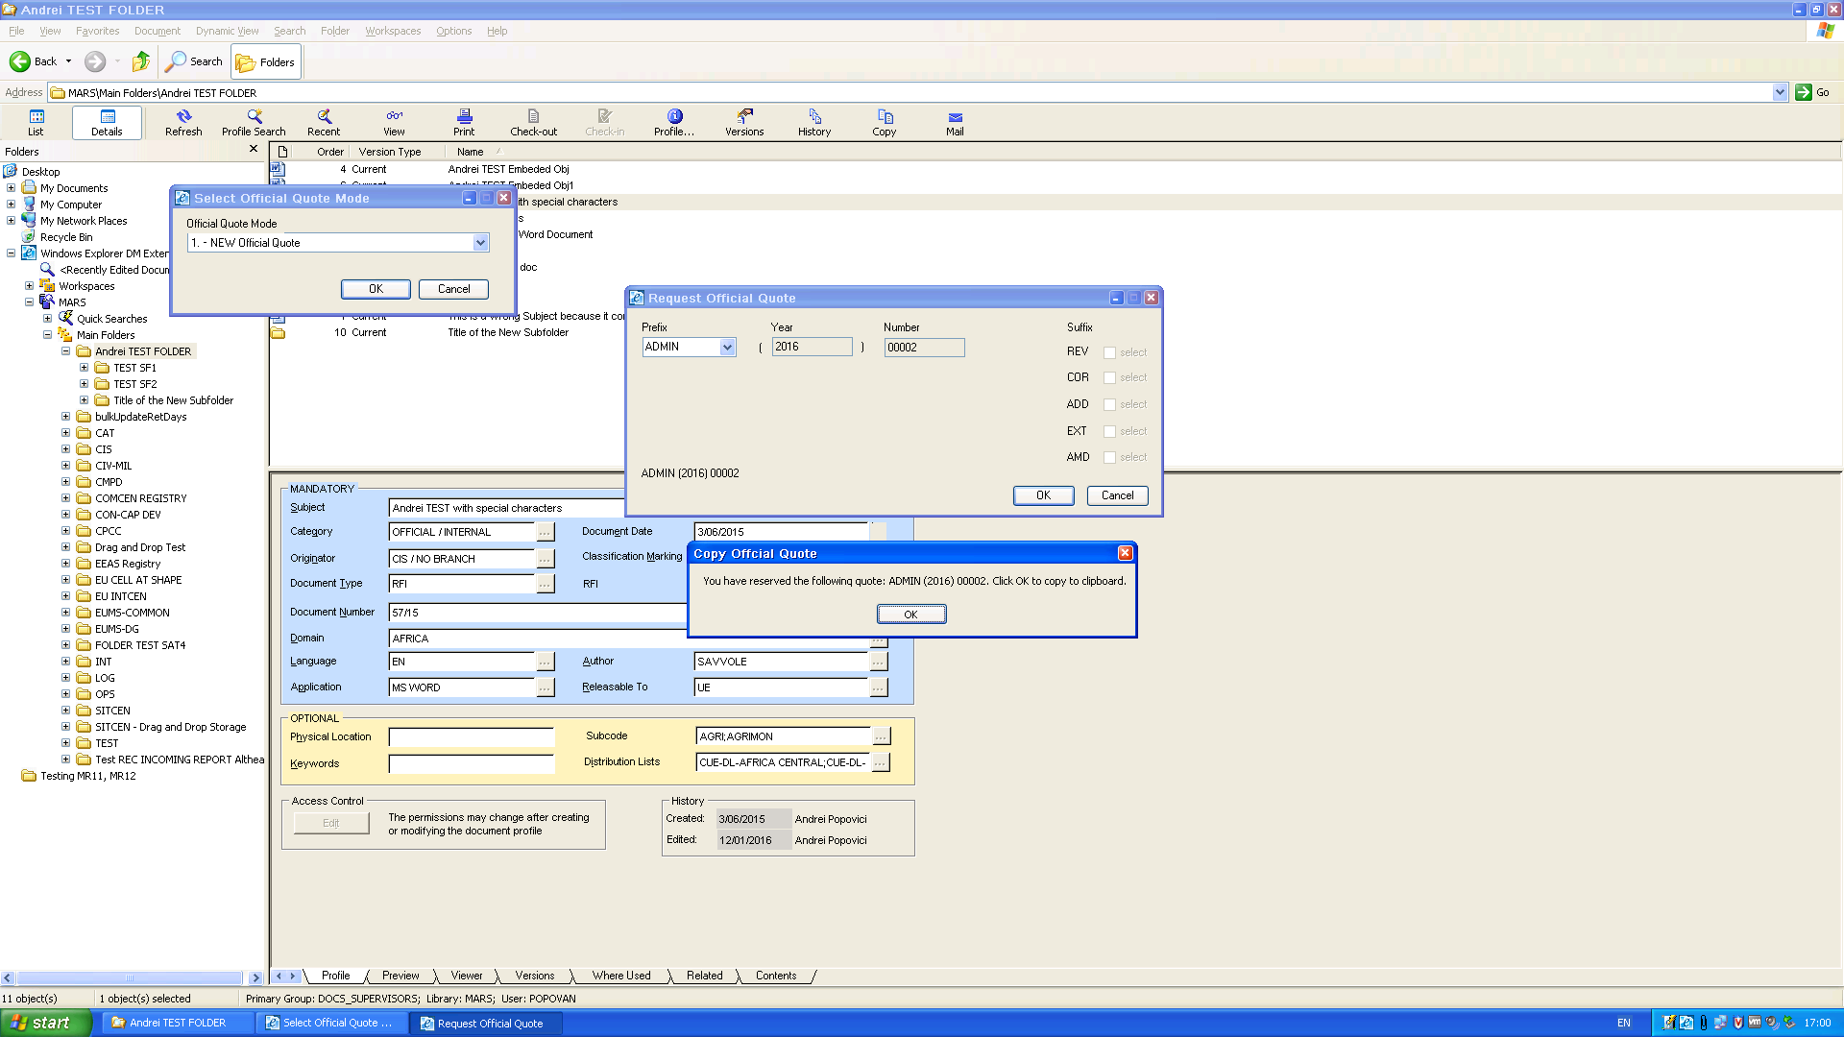
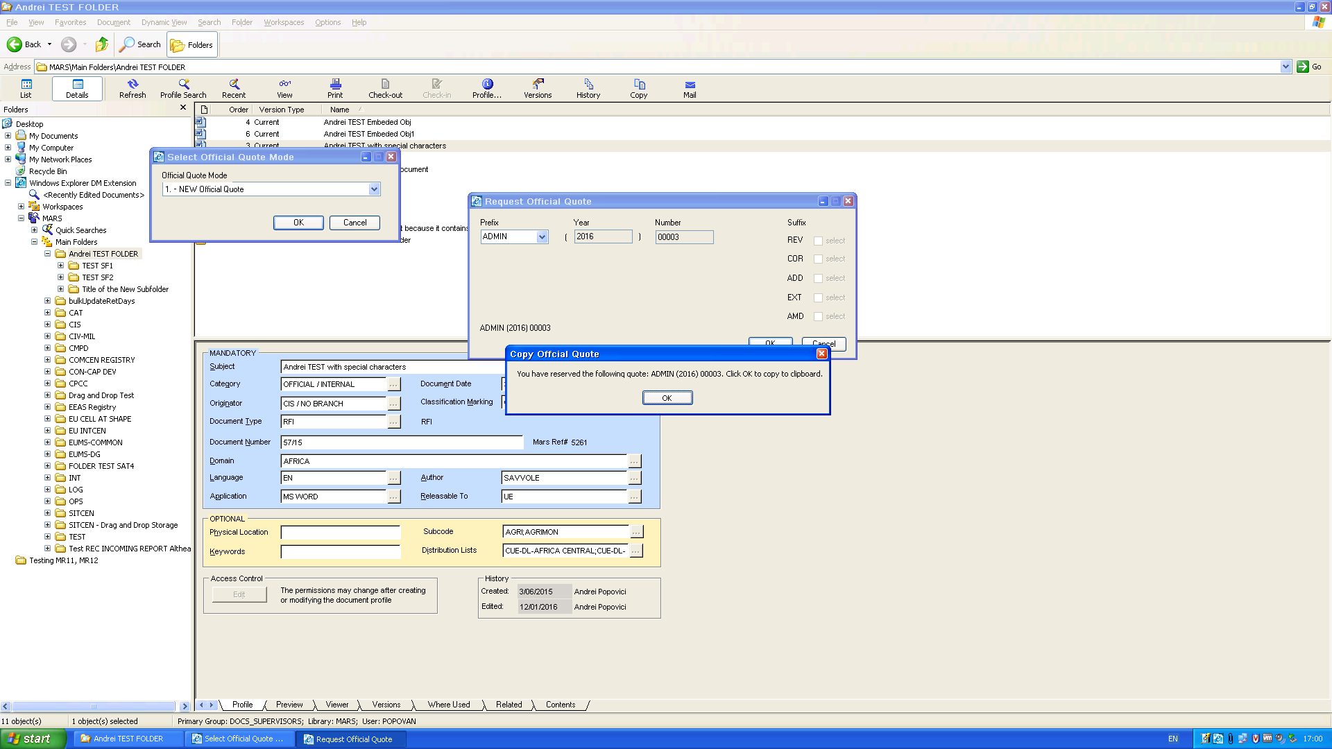

2.4 The final list:
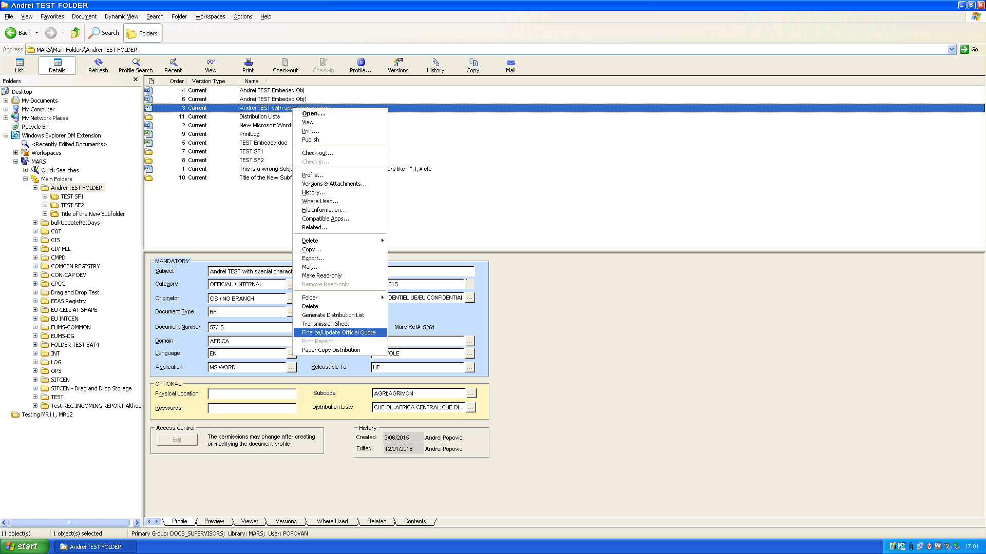
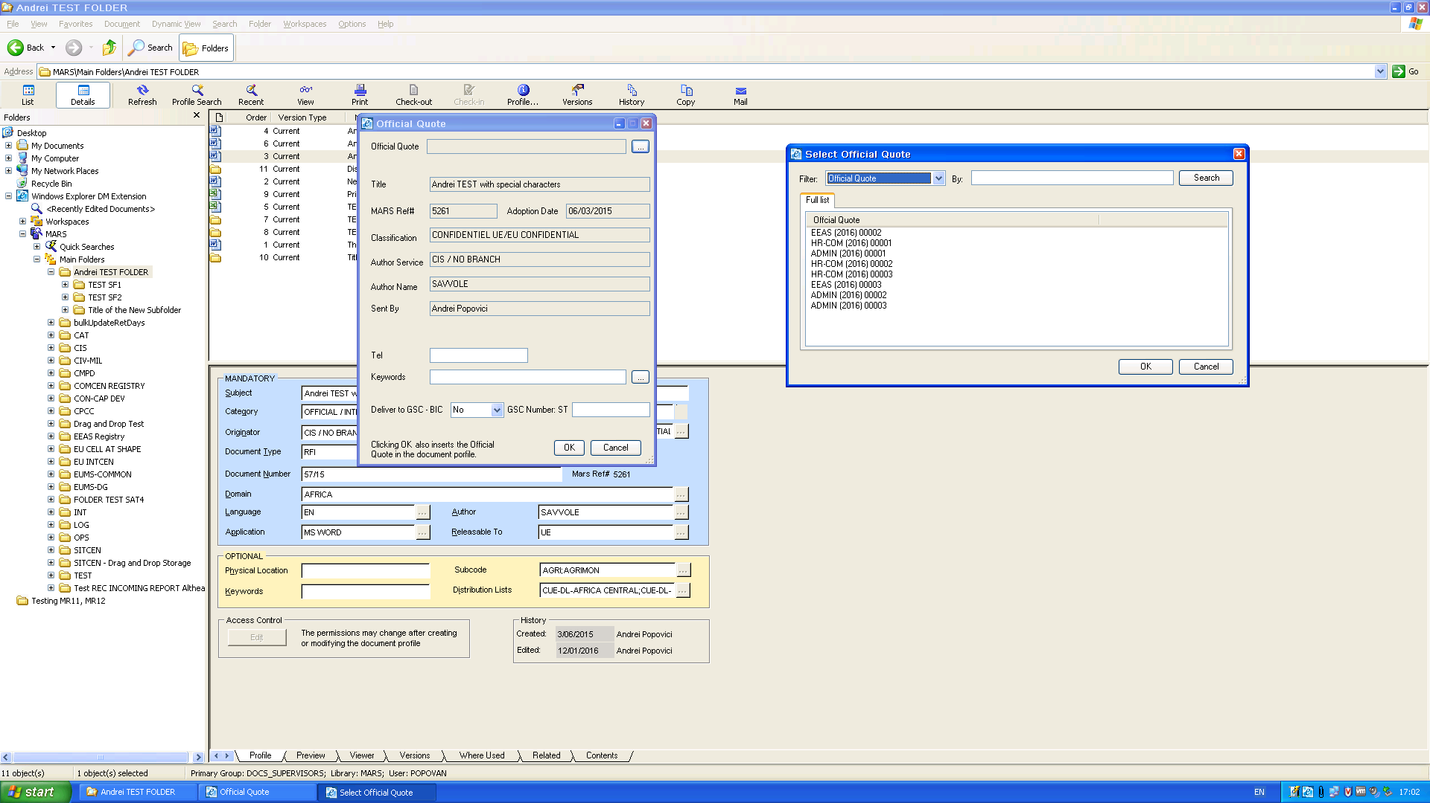

The Official Quote Log:
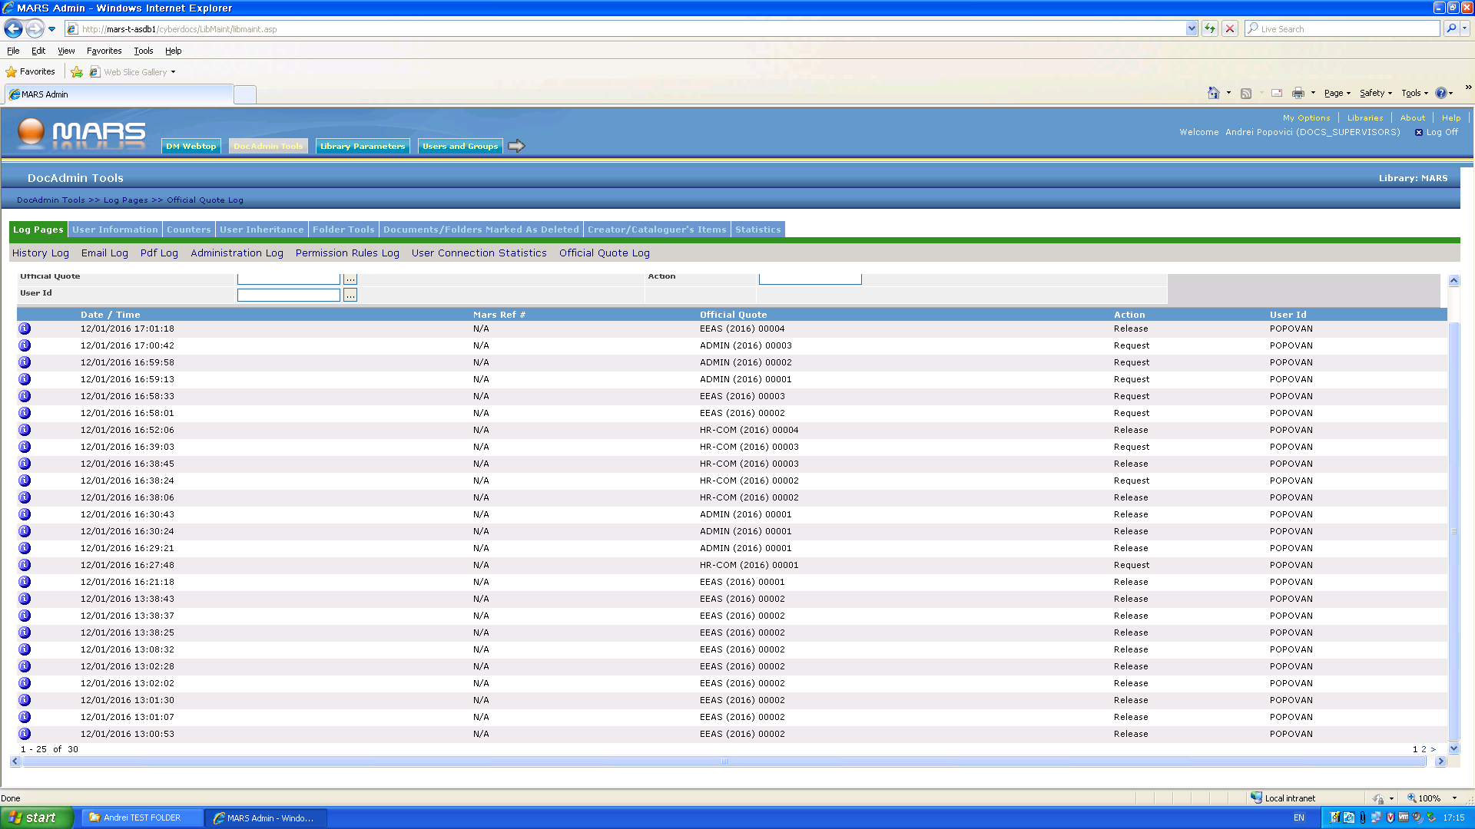
We see that EEAS00001 has been booked at 16:21:18 ( and we saw it the first time we logged in after logging off), however, EEAS 00001 is not available in the Official Quotes closed list.

Conclusion:
All Official Quotes have been saved properly, except for EEAS 00001 which is not available in the list.

